Design Document
  - Project Description
This is my personal homepage — a window into who I am rather than a professional portfolio. I built it as part of my CS Web Development course at Northeastern, but the content is genuinely personal: my travels, my climbing, my cooking, and the CS projects I've enjoyed most.
I was born in the UK, grew up in Hong Kong and Singapore, and my family now lives in Bath. I'm currently finishing an MS in Computer Science at Northeastern in Boston. Before that I spent four and a half years in enterprise SaaS sales at Darktrace and Panopto. The homepage reflects both sides of that — someone who builds things and someone who has lived in a lot of different places.
The site has three pages: a homepage with a polaroid photo collage, projects section, and about snippet; a background page with my full story and career timeline; and a third page generated using AI about the science of bouldering grades. It is built with vanilla HTML5, CSS3, and ES6 JavaScript with no frameworks or libraries, and deployed on GitHub Pages.
  - User Personas
Sarah R. — Tech Recruiter Sarah works in-house at a Series B AI startup. She has come across Tom's LinkedIn and wants to get a sense of who he is beyond his resume. She's not deeply technical but wants to understand his background and personality quickly. She needs to find contact information easily, get a feel for who Tom is as a person, and find a link to his full professional portfolio. Her frustrations are pages that feel generic, no clear personality, and buried contact links.
Marcus K. — Hiring Manager Marcus is a Head of Sales Engineering at an AI startup who has already seen Tom's professional portfolio and wants to learn more about him as a person before an interview. He visits the homepage to understand Tom's interests and background outside of work. He wants to see that Tom is a real, interesting person with genuine hobbies — not just a list of credentials. He appreciates the climbing and travel content as conversation starters.
Professor John Alexis Guerra Gómez — Course Instructor John is the professor for this web development course at Northeastern. He visits the site to assess whether the work meets the assignment brief and demonstrates real understanding of the material. He is an expert in data visualisation and HCI so he will notice whether interactive components are thoughtfully designed. He wants to see clean well-structured code, meaningful personal content, correct use of ES6 modules, semantic HTML, and a creative component that is genuinely original. His frustrations are missing meta tags, non-semantic HTML, poor folder structure, and creative components that are not actually creative.
  - User Stories
US-01 — Sarah, Tech Recruiter Sarah opens the homepage from Tom's LinkedIn profile and has two minutes between calls. She wants to quickly answer: is this person interesting and easy to contact? She scrolls through the hero section, reads the one-liner about growing up in Hong Kong and Singapore, glances at the photo collage, and clicks the email link in the contact section. Design decision: the hero section leads with a personality-forward headline and personal description rather than a job title. Contact links are prominent at the bottom of every page.
US-02 — Sarah, Tech Recruiter After a good first impression, Sarah wants to forward the link to her hiring manager with a short note about Tom. She needs something memorable to say. She recalls the polaroid collage — the climbing photos and the Colombia travel shot — and uses those as talking points. Design decision: the polaroid collage is the first thing below the hero, immediately giving visitors something personal and visual to remember.
US-03 — Professor Guerra Gómez, Course Instructor John opens the homepage to grade it against the rubric. He checks the page source and confirms the script tag uses type="module". He inspects the folder structure and sees css, js, and images organised correctly. He interacts with the polaroid collage, clicks a filter button, and watches photos hide and show. He clicks a photo and the lightbox opens. He checks that all images have alt text and that no divs are being used as buttons. Design decision: all interactive elements use semantic HTML — button tags for filters, article tags for polaroids. All images have descriptive alt text.
US-04 — Professor Guerra Gómez, Course Instructor John navigates to the AI page to check it meets the third-page requirement. He reads the disclosure banner confirming it was generated with Claude Sonnet 4 and notes the prompt is included. He is satisfied it is clearly labelled and content-rich rather than a placeholder. Design decision: the AI page is a full article with multiple sections. The disclosure is the first thing visible after the nav.
US-05 — Michael, Friend Michael opens the homepage on his phone after Tom sends him the link. He immediately scrolls to the photo collage and taps through the climbing photos, recognising the Rockspot gym. He filters by Travel and looks at the Colombia and Morocco photos. He reads the hero tagline and laughs at the Bath Rugby Finn Russell reference in the about section. Design decision: the collage works on mobile, the tone is casual and personal throughout, and the about section includes specific personal details that feel human rather than professional.
US-06 — Michael, Friend Michael wants to show his girlfriend the homepage but can't remember the URL. He searches "Tom Howes Boston" and finds it easily. He clicks through to the About page and reads the Hong Kong and Singapore background, which he didn't know about. He sends her the link. Design decision: the page has proper meta description and author tags so it's findable, and the About page tells the full story in a casual readable way.
  - Design Mockups
Index.html
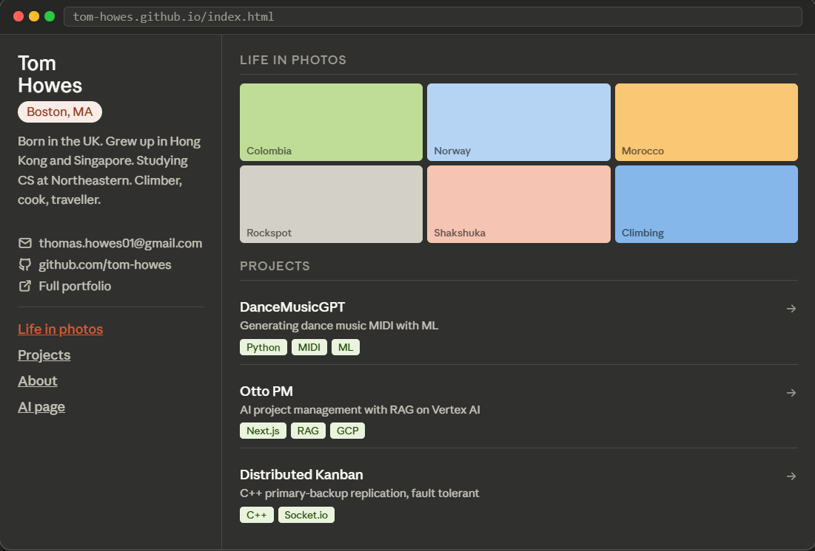

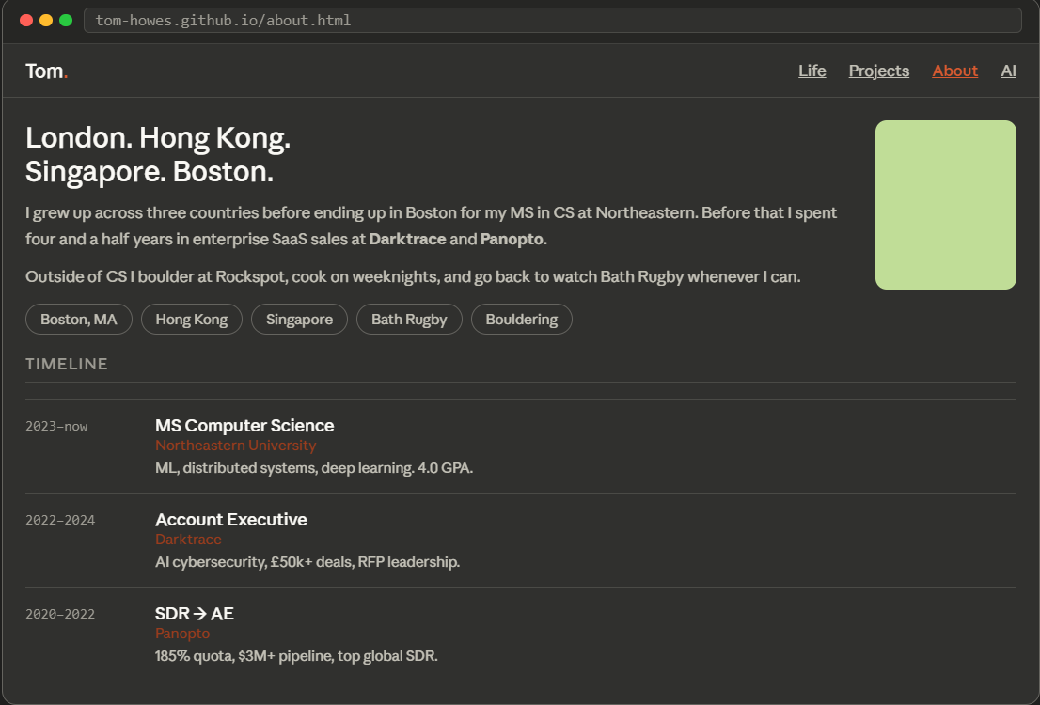
about.html

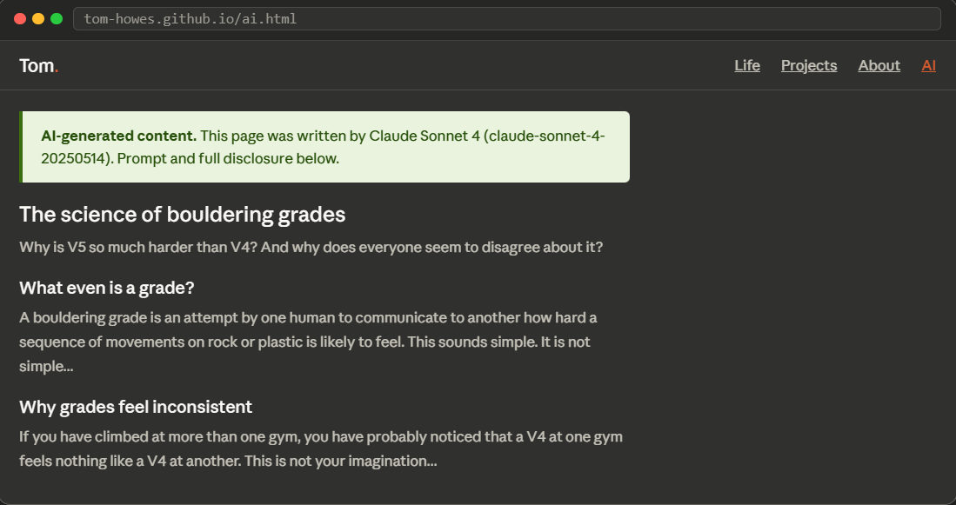
ai.html

